**SMS Based Electric Consumption Monitoring System with Energy Direct Cost Calculation and Power-On Delay Switch Mechanism: Design and Evaluation**

*By: Jonelle H. Tablada*

*Khorina O. Aguilar*

1. **Introduction**

The total consumed electricity in the Philippines for the year 2015 to 2018 was 127.6 billion kilowatt hours based on (Gumaru & Banta, 2019). Furthermore, the country is densely populated with around 104.9 million people and with 19.9 million households. On average, the household electricity consumption in the country was about 248.1-kilowatt hours in 2015, where electricity was used primarily for lighting purposes, cooking, recreation and space cooling (Sanchez, Household electricity consumption per capita in the Philippines from 2000 to 2016, 2020). With the usage of other energy products, electricity is still the leading used energy. From 2008 to 2017, the consumption of electricity in different sectors of the country increased over the years. The residential sector and industrial sector were one of the major consumers of electrical energy. A sign of slowing down is nowhere near since most of the sectors rely on electricity for their operations. Although some parts of the country, especially the rural areas where families belong to the lowest income brackets used kerosene for lighting. Majority of the Filipinos belonging to the urban areas have access to electricity. Due to its demand, CO2 emissions for Philippines was 150.6 million tons. CO2 emissions of Philippines increased from 25.7 million tons in 1970 to 150.6 million tons in 2019 growing at an average annual rate of 3.90% based on (Knoema, 2019). Electricity is derived from different sources of energy produced by power plants. For electricity to be produced, power plants harness different resources. As of 2018, most of the power generated by the power plants in the country came from coal. Coal remains the major source of electricity for Luzon, Visayas and Mindanao. The country has a total of 208 power plants: 21 coal power plants, 52 oil/gas/diesel-fired power plants, 135 renewable energy power plants, according to (Austrade, 2017).

Previously, most users are not aware of their electricity consumption since the utility bills are issued by the utility company only at the end of each month, without giving any details or break-down of the utilization by (Isa, Latip, Zaini, & Alias, 2015). By relying on the information given by the utility company, most consumers are ignorant on the consumption of power they used daily. Assumptions are always made and sometimes, assuming leads to overloading due to a less knowledge when it comes to this kind of matter. Many consumers become power dependent without any understanding on the maximum current and voltage available per household. State of a power system is typically classified as being one of four possible types – normal, alert, emergency and restorative. An emergency state is one in which one or more of the physical operating limits are violated (e.g., line overloads, over/under voltages, over/under frequency) (Verma, Banerjee, Thakur, Sahay, & Sengupta, 2014). During alert as well as emergency condition, system operator should take corrective action so that system is brought back to its normal operating condition. It is then concluded that discerning conditions is possible anytime without notice. During this certain condition, power-dependent appliances may at risk from power-surges.

This issue is solvable when monitoring of current and voltage is available to the common user and households. Also, getting the amount of power consumption daily will motivate individual to save due to the high price of kilo-watt hour. Electricity prices in the Philippines are amongst the highest in Southeast Asia and is considered relatively high compared to global standards, at roughly $0.20 per kWh, thanks to heavy reliance on imported fossil fuels and uncompetitive market structures based on (Saulon, 2019). Aside from that, when monitoring is available, the power-on delay which is a first solution in protecting the appliance from power surges, will be used. Based on (Elamvazuthi, Khan, Shaari, Sinnadurai, & Amudha, 2012), electrical power consumption monitoring on a real-time basis is essential to keep electric consumption from exceeding the critical demand level. SMS Based Electric Consumption Monitoring System with Energy Direct Cost Calculation and Power-On Delay Mechanism will monitor users’ consumption on real time basis to measure the remaining allowable current and voltage to be used. This will prevent the line from overloading and damage on wires, outlets or even to the appliances by not receiving enough power. Also, this monitoring will calculate the daily power consumption, and generate initial bill with manually inputted kilo-watt hour to widen the flexibility in case changes are made. Daily usage will be sent to the user for them to monitor the consumption and encouraged everyone to save. The high tariff on electricity will motivate consumers to save if they have basis on how much truly they spend on electricity alone per day. Consumer will also have an estimate on how much they are to pay on monthly basis before the bill arrives. The transmission is done wirelessly while data for hourly consumption will be saved to the SD Card. Data saved will be used for future usage and analysis. This monitoring will also cater the amount of electricity a breaker gets, if household receives higher than the specified amount or there are power surges, Power-On Delay will be triggered. This will protect the appliances from getting too much power. Due to this, house owners will have an automatic protection without being manually monitored from time to time.

The study aims to minimize the usage of electricity through monitoring of voltage, current and power factor with the use of microcontroller and sensors. Monitoring also includes keeping energy consumption with the calculation of monitory equivalent. It aims to promote awareness to the significant users in terms of utilization of energy, and protection of electronic appliances. The automation will lessen the work and offer accurate estimates in direct cost analysis and undertake timely lookout for power surges.

Moreover, monitoring is best observed especially when data being monitored is saved for future references. The best way to save data is through data storage.

**Significance of the study**

**Residential consumers**

The system can also be utilized in monitoring the everyday power consumption and the peak load occurrence of residential consumers. Also, this will promote to save energy through proper monitoring and will aid the conservation of electrical appliances against overpower and over current.

**Small and Medium Enterprises or SMEs**

This study is designed to also benefit the local SME players. Having an affordable and reliable power monitoring system can be of great help in policy making especially in energy conservation on SMEs. Knowledge in proper energy management can lead to lessen the establishment’s expenses.

**Distribution Utilities**

The distribution and transmission sectors will benefit through the minimum dealings on block-outs and brown-outs, or in some worst cases, red alerts which happened last April to May 2020 based on NEA administrator Edgardo Masongsong. When objective is addressed, the environment will also benefit due to minimal CO2 emission. Also, with the utilization of this system, electric distribution utilities can now provide consumers with a more transparent power consumption monitoring for their power usage.

**Future Researchers**

This study may serve as a guide for future researchers who will venture into similar system design. New studies maybe developed from the concept which this study evolved on.

1. **Objective**

The main objective of the study is to address the unawareness of electric customers through the development of SMS Based Electric Consumption Monitoring System with Energy Direct Cost Calculation and Power-On Delay Mechanism.

Specifically aim to:

1. To calculate the Energy Direct Cost in daily and monthly basis,
2. To notify the user wirelessly using SMS with the estimates,
3. To protect the appliances from any power surges with the development of Power-On Delay, and
4. To create a system that will save data for the future usage.
5. **Materials and Methods**
6. **System’s Block Diagram**

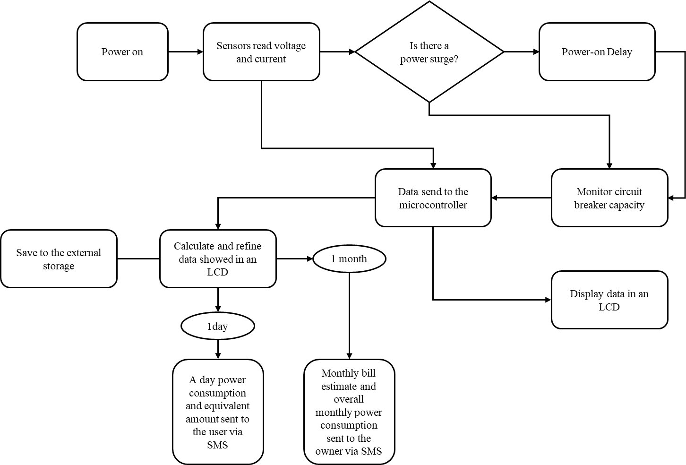

Figure 1. System’s Block Diagram

Figure 1 shows the process of data through blocks. Once the system is interconnected to the supply, automatically it will be switched on. Then, the system will read the data. The data gotten are the voltage and current. This raw data will be used to calculate power factor and power consumption. The reading is measured on minutes using the raw data, voltage and current, then will be calculated in an hourly average basis. At the end of the day, depending on the time the owner is set, the system will notify on the consumption and bill on that day. Data on hourly basis and date will be saved in an external storage. The monthly consumption is calculated based on the consumption on daily. This will give an estimate to the owner on the possible bill he will be getting on that month.

In addition, the system has its own Liquid Crystal Display (LCD) for the display of voltage, current. Also, the system has its built-in keypad to set the set kilowatt-hour (kWh) cost to widen the flexibility of the system for sustainability. Aside from that, the system will monitor a power surge to protect the appliances from damaged which occur when the flow of electricity is interrupted, then started again, or when something sends electricity flowing back into the system. Power-on delay is applied to solve the said issue.

1. **Architectural Design of the System**

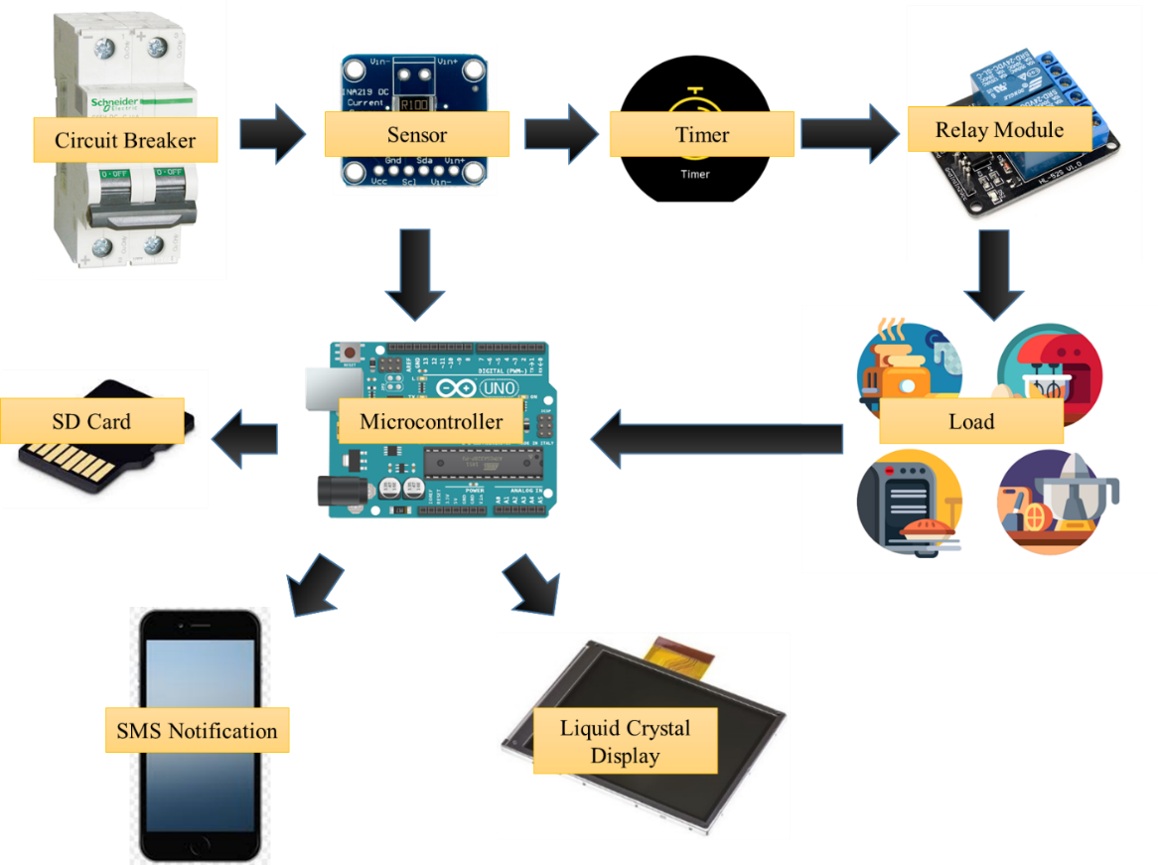

Figure 2. Architectural Design of the System

Figure 2 shows the systems’ architectural design and the materials used. The current and voltage from the circuit breaker will be used as the data read by the AC Voltage and Current Sensor from the main, also this area here will measure the overall load voltage and current used by the household, then calculate the remaining current/voltage for the possible usage. This will prevent overloading and protect the appliances from getting insufficient power. The monitoring will be shown in a Liquid Crystal Display (LCD). The microcontroller will brain the whole system, from getting the data from the sensor to displaying and sending it to the owner via SMS. The calculation of bill daily and monthly, also the calculation of remaining current and voltage available will be managed by the microcontroller.

On the side of protecting the load whenever there is an electrical surge, there will be a power-on delay. This will lessen the voltage surge and voltage fluctuations which remarkably common as the power lines adjust to the sudden influx of power. This power imbalance can last between a few seconds to a few minutes and can cause significant damage to the appliance during that time.

1. **Energy Direct Cost Calculation**

Energy Direct Cost = Power Consumption * kWh

∑Energy Direct Cost for 30 days

1. **Review of Related Literature**

Electricity prices in the Philippines are amongst the highest in Southeast Asia and is considered relatively high compared to global standards, at roughly $0.20 per kWh, thanks to heavy reliance on imported fossil fuels and uncompetitive market structures based on (Asian Power: Power Utility, 2019). According to (Ahmed, 2019), there are outstanding commitments of 4.8GW in coal projects slated for commercial operation by end-2019. This leads to a potential for up to $9.5b in stranded asset risk, with a broader risk beyond 2019 of 10,423MW - equivalent to $20.9b.

Based on (Sanchez, Electrical energy consumption in the Philippines 2008-2017, 2020), electricity is still the leading used energy in the Philippines. From 2008 to 2017, the consumption of electricity in different sectors of the country increased over the years. The residential sector and industrial sector were one of the major consumers of electrical energy. A sign of slowing down is nowhere near since most of the sectors rely on electricity for their operations. Although some parts of the country, especially the rural areas where families belong to the lowest income brackets used kerosene for lighting. Majority of the Filipinos belonging to the urban areas have access to electricity. On average, the household electricity consumption in the country was about 248.1-kilowatt hours in 2015, where electricity was used primarily for lighting purposes, cooking, recreation and space cooling.

On the other hand, some negative occurrences may happen during the unexpected tricking off electricity, and one of these is power surge. Power surges occur when the flow of electricity is interrupted, then started again, or when something sends electricity flowing back into the system. Surges can range from five or ten volts when you turn on your hair dryer to thousands of volts if lightning strikes a transformer, based on (Alliant Energy Corp., 2021). Furthermore, (Smith & Standler, 1992) emphasized that disturbances on the mains can affect electronic equipment in two ways: damage and upset. An example of damage is a surge from lightning that causes components to explode. An example of upset is a digital clock or video cassette recorder that needs to be reprogrammed after a power interruption. Upset is often caused by inadequate voltage (sags, outages, brownouts), while both upset and damage can be caused by high-voltage transients.

Conservation of energy and protection to electronic equipment is solvable with the use of few methods, one is monitoring. Based on (Pro Circuit Inc, Industrial Electric, Regular Maintenance, 2020), power quality monitoring measures the supply of power to AC power units. This includes voltage, current or power factor. A sudden, or even a gradual, change in power can greatly affect your power quality, reducing your efficiency or causing other problems. When there is an interruption of power – be it a dip, a spike, a surge or an outage –the service, and machines, stops, even if only briefly. Even a brief interruption, especially several over many days, weeks or months, can lead to significant decreases in efficiency and productivity. When suffer these interruptions, the output, in turn, suffers as well.

The study of (Luechaphonthara & A, 2019) entitled “IOT based application for monitoring electricity power consumption in home appliances”, proposed a Wi-Fi enabled simple low-cost electricity monitoring device that can monitor the electricity consumption on home appliances which helps to analyses the consumption of electricity on a daily and weekly basis. (Luechaphonthara & A, 2019), emphasized that smart systems will help the consumer to monitor and do an analysis of power consumption in order to adjust the usage that will in turn help in lowering the electricity bill. However, Wi-Fi connectivity is not ideal in the Philippines. According to (Ordinario, 2017), the Philippines’s average connection speed was only at 2.8 Megabits per second (Mbps) for the third quarter of 2015, despite the high cost. This is significantly lower than the global average connection speed of 5.1 Mbps and the second slowest in the Asia-Pacific region.

Another study that highlights the importance of monitoring is the study of (Yang, et al., 2018) entitled “A Simple Wireless Sensor Node System for Electricity Monitoring Applications: Design, Integration, and Testing with Different Piezoelectric Energy Harvesters”. This study uses the dynamic power management ensures the system to work with different types of PZT EHs at a wide range of input power. Thus, the system is robust against fluctuation of the current in the electricity grid and requires minimum adjustment if EH unit requires exchange or upgrade. However, the transmission of data by this system was through Bluetooth connectivity. According to (Lonzetta, Cope, Campbell, Mohd, & Hayajneh, 2018), Bluetooth lacks a centralized security infrastructure, as a result, it has serious security vulnerabilities. Interference is also a problem when using this technology. The author also suggests for the use of Wi-Fi and Zigbee, yet these features are not ideal on areas with low internet connectivity like in the Philippines’ provinces and remote areas. Zigbee communication provides easy wireless installation of sensors at a lower cost and increases reliability using mesh networks. Although Zigbee has a capability of 250kbps which is more than enough for SMS, it is not intended for voice and data streaming because it consumes too much bandwidth and drains power quickly, thereby making it unsuitable for real time applications, based on the study of (Madan & Reddy, 2012).

Based on the above data, internet-based transfer of data is not ideal in the Philippines. According to (Soni & Tanwar, 2014) on their study, “Data Transfer without using Internet or Bluetooth”, SMS or Short Message Service could be boon for the world because one could send files even when there is shortage of internet balance. Also, there are features in the usage of SMS that make it viable and ideal for third world countries. According to (Okazaki & Taylor, 2006), SMS is adoptable due to four factors involved: perceptions of the ability to build the brand, location-based services, privacy/security concerns of mobile advertising, and technological conditions. Apart from that, (Downer, Meara, Costa, & Sethuraman, 2006) lay emphasis on the financial benefit of using SMS. Downer et al. said that it is cost effective especially on monitoring and reminder processes. Based on (Madan & Reddy, 2012), on the other hand, the main advantage of using SMS is that even if the network is busy or the user is outside the coverage area continuous effort of delivery is made. These features of the SMS make it ideal in areas with limited internet and unstable signals.

On the other hand, monitoring in this study also covers the Power-On Delay Mechanism. The Power-on-Delay will delay the electrical connection for ~3-5 minutes until the power stabilizes. By doing so, the appliance is protected from the expected post-brownout voltage surge, which in turn, ensures the continued safety and performance of the appliance, based on (Panther, 2020). (Balamiento, 1982) pointed out that sudden loss and recurrence of power can damage compressor-type appliances such as freezers, air conditioners, and refrigerators. (Homeres, 2020), on the other hand, empathizes the advantage of having Power-On Delay especially on the lifespan of appliances. He said that the 4-min delay function of the developed outlet box implies that it can further protect the electrical appliance from the abrupt recurrence of electricity caused by unexpected brownouts and high and low voltage level cut-off. Recently, (Singh, Kumar, Shabbir, & Zahid, 2019) presented the tripping circuit that protects domestic appliances from over/under voltage levels. The device permits the appliance to operate safely when the line voltage is 180-230 V; and the user can monitor the line voltage level through global system for mobile (GSM) communications. Aside from the existing research focusing on power-on delay, products and devices acting as power-on delay are also available in the market. However, these devices are only capable of delaying the connection between the power source and the appliances for a couple of minutes after the electricity’s back. Within the period when electricity is available regardless of any fluctuations, overload and underload, the device is incapable of detecting those. Yet, these fluctuations are triggers also for the damage of appliances, or any other directly sourced equipment. Also, this device is intended only for one (1) appliance. This make it exorbitant when applied to all available appliances at home, and the purpose is only to delay the power.

Provided the above piece of literature, it is given that Power-On Delay mechanism is essential in keeping the appliances safe from low voltage and high voltage. On this study, the application of Power-On Delay to the main circuit given that multimeters are available to measure the voltage and current, is a huge leap in terms of financial aspects and suitability. This method will not compromise that other unfocused equipment from being damaged due to surges and fluctuations.

# References

1. Ahmed, S. J. (2019). *Prospects Improve for Energy: More transparent bidding, pricing and risk .* Institute for Energy Economics and Financial Analysis.
2. Alliant Energy Corp. (2021). *Power surges cause & effect.* Retrieved from Alliant Energy's PowerHouse: https://www.powerhousetv.com/EnergyEfficientLiving/PowerQuality/PowerSurges#:~:text=Power%20surges%20occur%20when%20the,if%20lightning%20strikes%20a%20transformer
3. Asian Power: Power Utility. (2019). *Renewables may cut Philippines' electricity rates 30%.* Philippines: CHARLTON MEDIA GROUP.
4. Austrade. (2017). *Energy to the Philippines: Trends and Oppurtunities*. Retrieved from ustralian Trade and Investment Commission (Austrade): https://www.austrade.gov.au/australian/export/export-markets/countries/philippines/industries
5. Balamiento, N. (1982). *Electronic Enthusiasts Projects and Circuits (Vol. 1).* Manila: Electronic Hobbyists Publishing House.
6. Basorun, O. O. (2015). Home Appliances Power Management System. *Journal of Advancement in Engineering and Technology* .
7. Downer, S. R., Meara, J. G., Costa, A. C., & Sethuraman, K. (2006). SMS text messaging improves outpatient attendance. *Journal of the Australian Healthcare & Hospitals Association*, 389 - 396.
8. Elamvazuthi, I., Khan, M. K., Shaari, S. B., Sinnadurai, R., & Amudha, M. (2012). Electrical power consumption monitoring using a real-time system. *2012 IEEE Conference on Sustainable Utilization and Development in Engineering and Technology (STUDENT).* Kuala Lumpur, Malaysia: IEEE.
9. Gumaru, R. C., & Banta, R. (2019). A Comprehensive Study of Electricity Consumption of People in Each Region in the Philippines. *American Journal of Mechanics and Applications*, 45-48.
10. Homeres, J. L. (2020). Design, Construction, and Effectiveness of Electrical Outlet Box with Built-in High and Low Voltage Cut-off and Power-on Delay Circuit. *Mindanao Journal of Science and Technolog*, Vol. 18 (1) (2020) 35-50.
11. Isa, M. A., Latip, M. F., Zaini, N., & Alias, Y. F. (2015). Android-based application for real time energy monitoring of domestic electricity. *2015 IEEE Conference on Systems, Process and Control (ICSPC).* Bandar Sunway, Malaysia: IEEE.
12. Johansen, B., & Wedderkopp, N. (2010). Comparison between data obtained through real-time data capture by SMS and a retrospective telephone interview. *Johansen and Wedderkopp Chiropractic & Osteopathy*.
13. Knoema. (2019). *World Data Atlas*. Retrieved from Knoema: https://knoema.com/atlas/Philippines/CO2-emissions
14. Lonzetta, A. M., Cope, P., Campbell, J., Mohd, B. J., & Hayajneh, T. (2018). Security Vulnerabilities in Bluetooth Technology as Used in IoT. *Journal of Sensor and Actuator Networks*.
15. Luechaphonthara, K., & A, V. (2019). IOT based application for monitoring electricity power consumption in home appliances. *International Journal of Electrical and Computer Engineering (IJECE)*, 4988~4992.
16. Madan, V., & Reddy, S. (2012). GSM-Bluetooth based Remote Monitoring and Control System with Automatic Light Controller. *International Journal of Computer Applications*, Volume 46– No.1.
17. Okazaki, S., & Taylor, C. R. (2006). What is SMS advertising and why do multinationals adopt it? Answers from an empirical study in European markets. *Journal of Business Research* .
18. Ordinario, C. (2017, April 17). *For Filipinos, poor Internet connection a more bothersome issue than poverty, corruption.* Retrieved from Business Mirror: https://businessmirror.com.ph/2017/04/17/for-filipinos-poor-internet-connection-a-more-bothersome-issue-than-poverty-corruption/
19. Panther. (2020, May 27). *Why do you need a Power on Delay?* Retrieved from Panther Products Philippines, Inc.: https://panther.ph/why-you-need-a-power-on-delay/
20. Pro Circuit Inc, Industrial Electric, Regular Maintenance. (2020, January 30). *Power Quality Monitoring: 5 Benefits*. Retrieved from Pro Circuit Inc: https://www.procircuitinc.com/blog/5-big-benefits-power-quality-monitoring/
21. Sanchez, M. J. (2020, May 15). *Electrical energy consumption in the Philippines 2008-2017.* Retrieved from Statista: https://www.statista.com/statistics/1065506/philippines-electric-energy-consumption/#statisticContainer
22. Sanchez, M. J. (2020, December 15). *Household electricity consumption per capita in the Philippines from 2000 to 2016.* Retrieved from Statista: https://www.statista.com/statistics/600115/household-consumption-of-electricity-per-capita-in-the-philippines/
23. Saulon, V. V. (2019). *Renewable energy could cut electricity rates by 30% — report.* BusinessWorld Publishing.
24. Singh, R., Kumar, R., Shabbir, R. H., & Zahid, A. (2019). Over/Under Voltage Tripping Circuit for Distributed System Load with GSM alert using Microcontroller. *International Journal of Innovative Technology and Exploring Engineering (IJITEE)*, Volume-8 Issue-9.
25. Smith, S., & Standler, R. (1992). The effects of surges on electronic appliances. *IEEE Transactions on Power Delivery* (pp. 1275 - 1282). IEEE.
26. Soni, V., & Tanwar, S. (2014). Data Transfer without using Internet or Bluetooth. *International Journal of Scientific & Engineering Research*, Volume 5.
27. Verma, U. K., Banerjee, S., Thakur, M. K., Sahay, S. K., & Sengupta, A. B. (2014). Grid monitoring tool — A case study of ERLDC, Kolkata. *2014 Eighteenth National Power Systems Conference (NPSC).* Guwahati, India: IEEE.
28. Yang, Z., Zarabi, S., Fernandes, E., Rua-Taborda, M.-I., Debéda, H., Salehian, A., . . . Wei, L. (2018). A Simple Wireless Sensor Node System for Electricity Monitoring Applications: Design, Integration, and Testing with Different Piezoelectric Energy Harvesters. *MDPI*.
29. **Schedule of Study**



1. **Cost**